[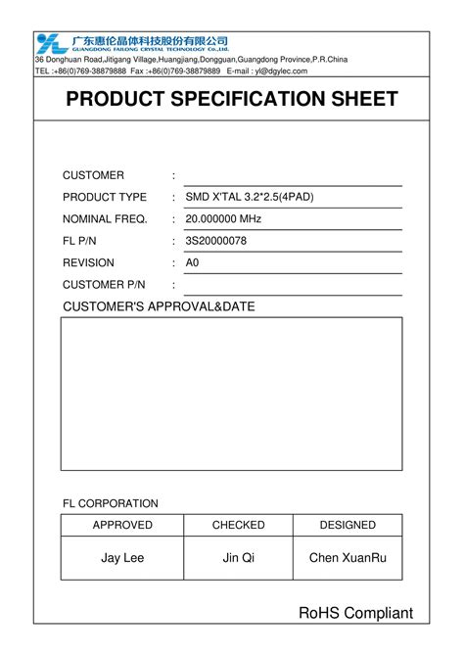](https://www.typecalendar.com/spec-sheet.html)

Certainly! Below is a comprehensive Product Specification Sheet for your optimized aftershave toner formula, formatted for Microsoft Word. This document includes detailed product information, usage instructions, and safety guidelines.

**Product Specification Sheet: Aftershave Toner**

**Product Name:** Aftershave Toner  
**Product Type:** Post-Shave Toner  
**Intended Use:** Applied post-shaving to soothe skin, minimize irritation, and prevent ingrown hairs  
**Target Market:** Men's grooming products  
**Skin Types:** Suitable for all skin types  
**Packaging:** 4 fl oz (118 mL) amber glass bottle with spray nozzle  
**Shelf Life:** 12 months from date of manufacture  
**Storage Conditions:** Store in a cool, dry place away from direct sunlight([safetysheets.business.xerox.com](https://safetysheets.business.xerox.com/wp-content/uploads/2023/09/A-10689.en-us.pdf?utm_source=chatgpt.com), [Scribd](https://fr.scribd.com/document/791195706/Aftershave-Document?utm_source=chatgpt.com))

**Ingredient Composition:**

| **Ingredient** | **Function** | **Percentage (%)** |
| --- | --- | --- |
| Isopropyl Alcohol (70%) | Antiseptic, astringent | 66.7 |
| Witch Hazel (Alcohol-Free) | Astringent, anti-inflammatory | 16.7 |
| Aloe Vera Juice | Moisturizer, soothing agent | 16.7 |
| Salicylic Acid (1.5%) | Exfoliant, unclogs pores | 1.5 |
| Propylene Glycol | Solvent for salicylic acid | 1.0 |
| Vegetable Glycerin | Humectant, skin conditioning | 2.8 |
| Allantoin | Skin protectant, soothing agent | 0.2 |
| Vitamin E (Tocopherol) | Antioxidant, skin conditioning | 0.8 |
| Essential Oils (Optional) | Fragrance, additional skin benefits | 0.1 |

*Note: Percentages are approximated for illustrative purposes.*

**Physical and Chemical Properties:**

* **Appearance:** Clear to slightly hazy liquid
* **Color:** Colorless to pale yellow
* **Odor:** Mild, characteristic of essential oils used
* **pH Range:** 4.5 – 5.5
* **Viscosity:** Low
* **Flash Point:** Approximately 22°C (due to isopropyl alcohol content)
* **Solubility:** Soluble in water and alcohol([safetysheets.business.xerox.com](https://safetysheets.business.xerox.com/wp-content/uploads/2023/09/A-10689.en-us.pdf?utm_source=chatgpt.com))

**Microbiological Standards:**

* **Preservatives:** Not required due to high alcohol content; however, microbial testing is recommended
* **Microbial Limits:** Total aerobic microbial count <100 CFU/g; absence of pathogens

**Stability and Shelf Life:**

* **Stability Testing:** Product remains stable for 12 months under recommended storage conditions
* **Packaging Compatibility:** Tested and compatible with amber glass bottles and plastic spray nozzles

**Regulatory Compliance:**

* **Labeling:** Compliant with ISO 22715 standards, including ingredient listing in descending order, usage instructions, and cautionary statements
* **Safety Testing:** Dermatologically tested; no adverse reactions reported
* **Claims:** Soothes skin, reduces post-shave irritation, prevents ingrown hairs

**Usage Instructions:**

1. **Cleanse:** Wash your face thoroughly with lukewarm water to remove loose hairs and excess dirt.
2. **Apply:** After shaving, apply a small amount to a cotton pad and gently sweep over the skin. Avoid contact with eyes.
3. **Dry:** Allow the toner to dry naturally; do not rinse off.
4. **Frequency:** Use after each shave or as needed.([Czech & Speake](https://www.czechandspeake.com/fragrance/journal-posts/5-ways-to-properly-put-on-your-fragrances-and-aftershaves/?utm_source=chatgpt.com))

**Cautionary Statements:**

* For external use only.
* Flammable: Keep away from heat and open flames.
* Avoid contact with eyes.
* Keep out of reach of children.
* Discontinue use if irritation occurs.([FORGED IRON FOR MEN](https://www.forgedironformen.com/product-page/polished-bracing-after-shave-toner?utm_source=chatgpt.com), [Czech & Speake](https://www.czechandspeake.com/fragrance/journal-posts/5-ways-to-properly-put-on-your-fragrances-and-aftershaves/?utm_source=chatgpt.com))

**Manufacturer Information:**

* **Company Name:** [Your Company Name]
* **Address:** [Your Company Address]
* **Contact:** [Phone Number] | [Email Address]
* **Website:** [Your Website URL]([Czech & Speake](https://www.czechandspeake.com/fragrance/journal-posts/5-ways-to-properly-put-on-your-fragrances-and-aftershaves/?utm_source=chatgpt.com))

**Document Control:**

* **Document Number:** [Document Number]
* **Revision Number:** [Revision Number]
* **Date of Issue:** [MM/DD/YYYY]
* **Prepared By:** [Preparer's Name]
* **Approved By:** [Approver's Name]([Google Cloud Storage](https://storage.googleapis.com/ddtjqvvmrcgole/what-is-a-technical-specification-sheet.html?utm_source=chatgpt.com))

To create a printable version of this specification sheet in Microsoft Word:

1. **Open Microsoft Word:** Launch the application on your computer.
2. **Create a New Document:** Select 'Blank Document' to start.
3. **Insert Title:** At the top, center-align and bold the title "Product Specification Sheet: Aftershave Toner."
4. **Input Content:** Copy and paste each section of the specification sheet into the document, maintaining the formatting for clarity.
5. **Add Tables:** Use the 'Insert Table' function to create tables for the Ingredient Composition and any other tabular data.
6. **Save the Document:** Click 'File' > 'Save As,' choose your desired location, enter a file name, and select 'Word Document (*.docx)' as the file type.
7. **Print the Document:** Click 'File' > 'Print,' select your printer, and adjust settings as needed before printing.

If you need assistance with label design or selecting suitable label materials and suppliers, feel free to ask!